

CS-110: Lab 09
One-Dimensional Arrays, Searching and Sorting

https://github.com/mmujtaba25/CS-110

Muhammad Mujtaba
CMD ID: 540040
mmujtaba.bese25seecs@seecs.edu.pk

  - Class: BESE 16B
  - Batch: 2k25

Task 1 [CLO 1]:

CODE:
#include <iostream>
#include <random>
#include <iomanip>
#include <sstream>
#include <string>

int getRandomPrintableChar(int minInclusive, int maxInclusive);
std::string getStringOfCharNTimes(char character, size_t times);
void printRow(const std::string &first, const std::string &second, const std::string &third);

int main()
{
constexpr size_t ARRAY_SIZE = 10;
int array[ARRAY_SIZE];

for (size_t i = 0; i < ARRAY_SIZE; i++)
{
array[i] = getRandomPrintableChar(1, 100);
}

printRow("Element", "Value", "Histogram");
for (size_t i = 0; i < ARRAY_SIZE; i++)
{
printRow(std::to_string(i), std::to_string(array[i]), getStringOfCharNTimes('*', array[i]));
}

std::cout << "\n";
return 0;
}

int getRandomPrintableChar(int minInclusive, int maxInclusive)
{
std::random_device rd;
std::mt19937 gen(rd());
std::uniform_int_distribution<int> distrib(minInclusive, maxInclusive);
return distrib(gen);
}

std::string getStringOfCharNTimes(char character, size_t times)
{
std::stringstream string_;
for (size_t i = 0; i < times; i++)
{
string_ << character;
}
return string_.str();
}

void printRow(const std::string &first, const std::string &second, const std::string &third)
{
constexpr size_t SPACING = 12;
std::cout << std::left << std::setw(SPACING) << first
<< std::left << std::setw(SPACING) << second
<< std::left << std::setw(SPACING) << third
<< "\n";
}

OUTPUT:
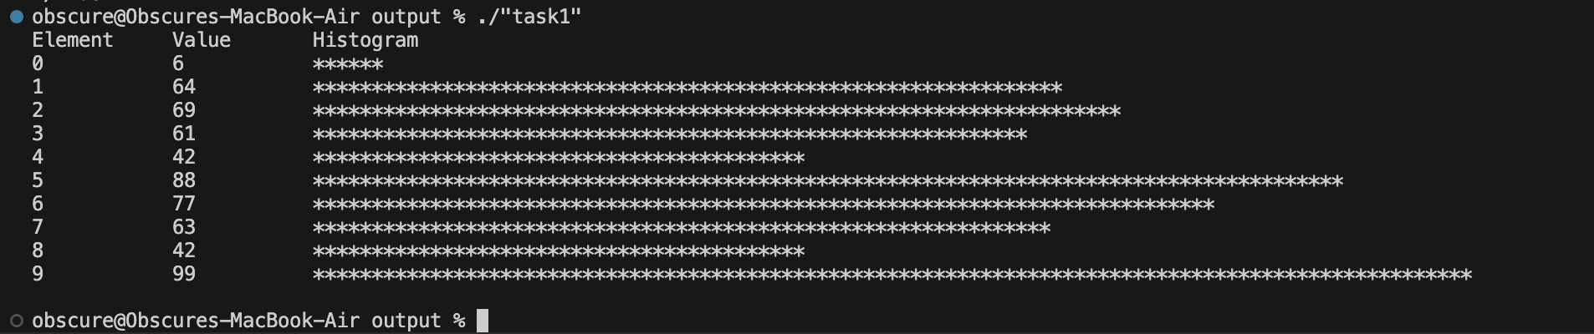
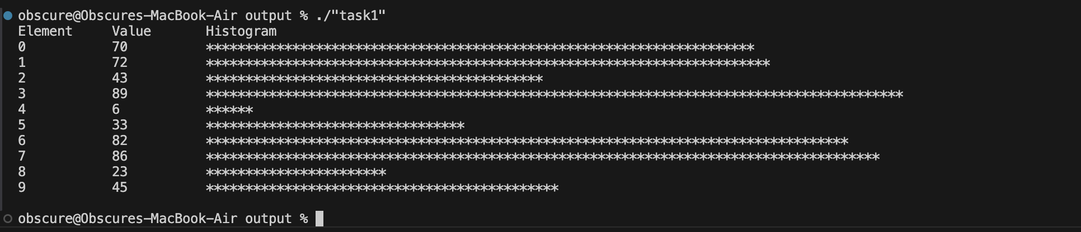

Task 2 [CLO 2]:

CODE:
#include <iostream>
#include <random>
#include <iomanip>
#include <sstream>
#include <string>
#include <cctype>

#define PRINT_LINE(message) std::cout << message << "\n"
unsigned char getRandomPrintableChar();

int main()
{
constexpr size_t ARRAY_SIZE = 10;
unsigned char array[ARRAY_SIZE];

for (size_t i = 0; i < ARRAY_SIZE; i++)
{
array[i] = getRandomPrintableChar();
}

int lowerCaseCount = 0;
int upperCaseCount = 0;
int digitCount = 0;
int specialCount = 0;

for (size_t i = 0; i < ARRAY_SIZE; i++)
{
std::cout << array[i] << "_";
if (islower(array[i]))
lowerCaseCount++;
else if (isupper(array[i]))
upperCaseCount++;
else if (isdigit(array[i]))
digitCount++;
else
specialCount++;
}
std::cout << "\n\n";

PRINT_LINE(upperCaseCount << " Upper Case Characters Count");
PRINT_LINE(lowerCaseCount << " Lower Case Characters Count");
PRINT_LINE(digitCount << " Digits Count");
PRINT_LINE(specialCount << " Special Characters Count");

return 0;
}
unsigned char getRandomPrintableChar()
{
auto getRandomChar = []() -> unsigned char
{
// static to reduce overhead by calling continously
static std::random_device rd;
static std::mt19937 gen(rd());
std::uniform_int_distribution<int> distrib(0, 255);
return distrib(gen);
};

unsigned char randomChar = getRandomChar();
// get a random characgter until
while (!isprint(randomChar))
{
randomChar = getRandomChar();
}
return randomChar;
}

OUTPUT:
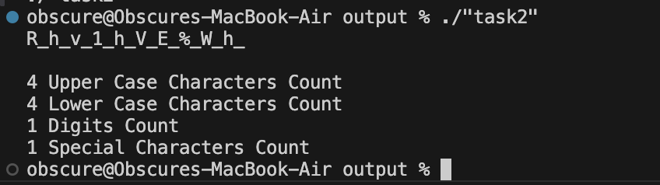
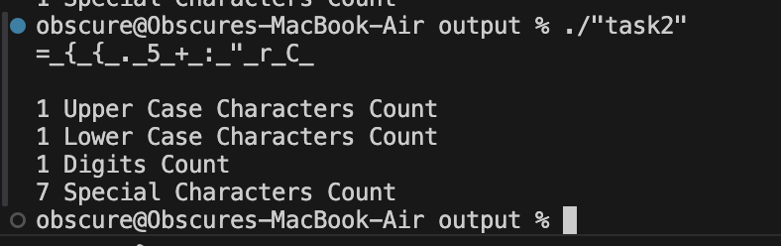
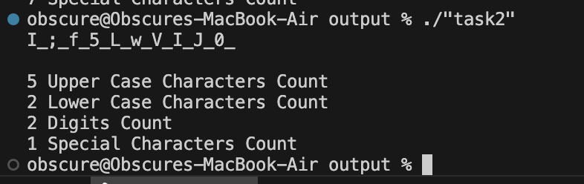

Task 3 [CLO 2]:

CODE:
#include <iostream>
#include <random>

double getRandomNum(double minInclusive, double maxInclusive);
double min(double array[], size_t size);

int main()
{
constexpr size_t TEST_ARRAY_SIZE = 10;
double testArray[TEST_ARRAY_SIZE];

for (size_t i = 0; i < TEST_ARRAY_SIZE; i++)
{
testArray[i] = getRandomNum(-100, 100);
}

std::cout << "ARRAY: ";
for (size_t i = 0; i < TEST_ARRAY_SIZE; i++)
{
std::cout << testArray[i] << " ";
}
std::cout << "\n";

std::cout << min(testArray, TEST_ARRAY_SIZE) << "\n";

// std::cin.get();
return 0;
}

double getRandomNum(double minInclusive, double maxInclusive)
{
if (minInclusive > maxInclusive)
std::swap(minInclusive, maxInclusive);

static std::random_device rd;
static std::mt19937 gen(rd());
std::uniform_real_distribution<double> distribution(minInclusive, maxInclusive);
return distribution(gen);
}

double min(double array[], size_t size)
{
double min = array[0];
for (size_t i = 0; i < size; i++)
{
if (array[i] < min)
{
min = array[i];
}
}

return min;
}

OUTPUT:
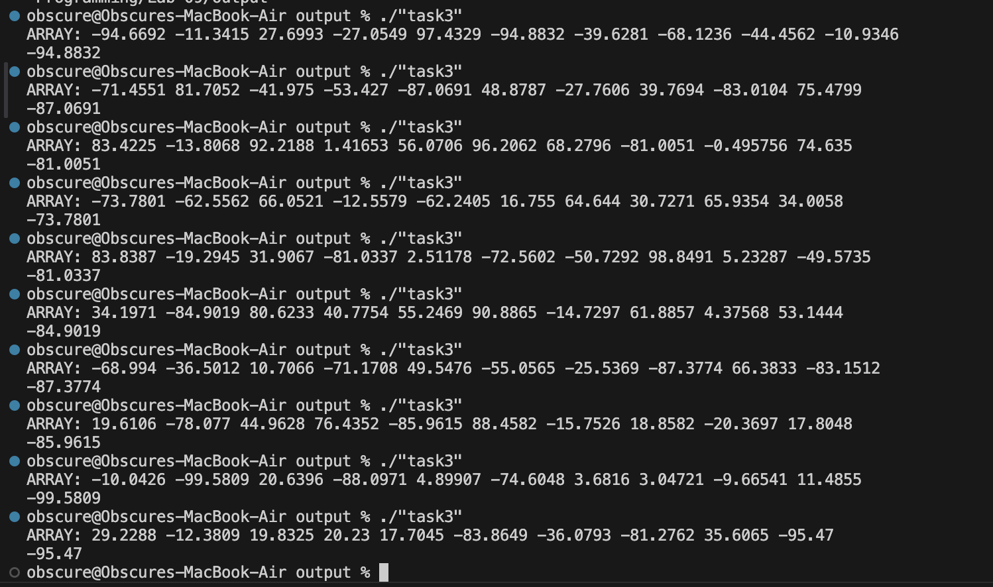

Task 4 [CLO 1]:

CODE:
#include <iostream>
#include <random>
#include <iomanip>

int getRandomNum(int minInclusive, int maxInclusive);
void sortArrayInPlace(int array[], const int size);
void printArray(int array[], const size_t size);

int main()
{
constexpr size_t TEST_ARRAY_SIZE = 10;
int testArray[TEST_ARRAY_SIZE];

for (size_t i = 0; i < TEST_ARRAY_SIZE; i++)
{
testArray[i] = getRandomNum(-100, 100);
}

std::cout << "BEFORE SORT: ";
printArray(testArray, TEST_ARRAY_SIZE);

sortArrayInPlace(testArray, TEST_ARRAY_SIZE);
std::cout << "AFTER SORT: ";
printArray(testArray, TEST_ARRAY_SIZE);

// std::cin.get();
return 0;
}

void printArray(int array[], const size_t size)
{
for (size_t i = 0; i < size; i++)
{
std::cout << std::right << std::setw(5) << array[i];
}
std::cout << "\n";
}

int getRandomNum(int minInclusive, int maxInclusive)
{
if (minInclusive > maxInclusive)
std::swap(minInclusive, maxInclusive);

static std::random_device rd;
static std::mt19937 gen(rd());
std::uniform_int_distribution<int> distribution(minInclusive, maxInclusive);
return distribution(gen);
}

void sortArrayInPlace(int array[], int size)
{
// use bubble sort algorithm
int i, j;
for (j = 0; j < size; j++)
{
for (i = 0; i < (size - 1); i++)
{
if (array[i] > array[i + 1])
{
std::swap(array[i], array[i + 1]);
}
}
}
}

OUTPUT:
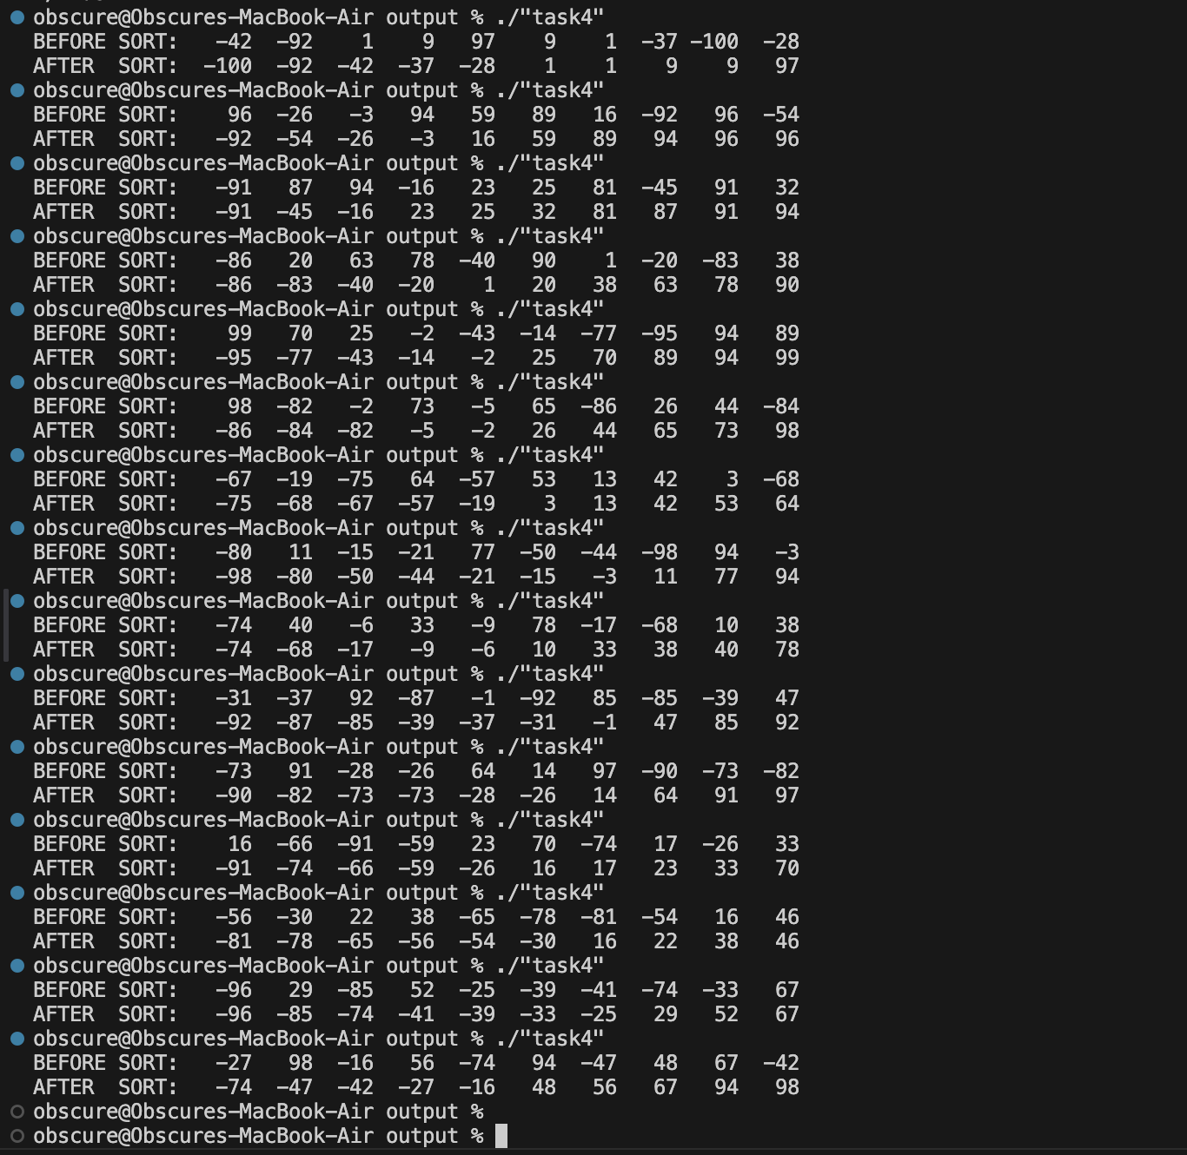

Task 5 [CLO 1]:

CODE:
#include <iostream>
#include <random>
#include <iomanip>

int getRandomNum(int minInclusive, int maxInclusive);
void sortArrayInPlace(int array[], const int size);
void printArray(int array[], const size_t size);

int getElementIndex(int array[], const size_t size, int element);

int main()
{
constexpr size_t TEST_ARRAY_SIZE = 100;
int testArray[TEST_ARRAY_SIZE];

for (size_t i = 0; i < TEST_ARRAY_SIZE; i++)
{
testArray[i] = getRandomNum(-999, 999);
}

sortArrayInPlace(testArray, TEST_ARRAY_SIZE);

std::cout << "SORTED ARRAY:\n";
printArray(testArray, TEST_ARRAY_SIZE);
std::cout << "\n";

int toFound;
std::cout << "Enter element to find from array: ";
std::cin >> toFound;

std::cout << "[" << toFound << "] at index " << getElementIndex(testArray, TEST_ARRAY_SIZE, toFound) << "\n";

// std::cin.get();
return 0;
}

void printArray(int array[], const size_t size)
{
constexpr size_t COLUMNS = 5;
for (size_t i = 0; i < size; i++)
{
std::cout << "[" << std::setw(4) << std::right << array[i] << " @ " << std::setw(4) << std::left << i << "] ";
if (i % COLUMNS == COLUMNS - 1)
{
std::cout << "\n";
}
}
std::cout << "\n";
}

int getRandomNum(int minInclusive, int maxInclusive)
{
if (minInclusive > maxInclusive)
std::swap(minInclusive, maxInclusive);

static std::random_device rd;
static std::mt19937 gen(rd());
std::uniform_int_distribution<int> distribution(minInclusive, maxInclusive);
return distribution(gen);
}

void sortArrayInPlace(int array[], int size)
{
// use bubble sort algorithm
int i, j;
for (j = 0; j < size; j++)
{
for (i = 0; i < (size - 1); i++)
{
if (array[i] > array[i + 1])
{
std::swap(array[i], array[i + 1]);
}
}
}
}

int getElementIndex(int array[], const size_t size, int element)
{
int min = 0;
int max = static_cast<int>(size) - 1;
int firstIndex = -1;

while (min <= max)
{
int mid = (min + max) / 2;
if (array[mid] > element)
max = mid - 1;
else if (array[mid] < element)
min = mid + 1;
else
{
firstIndex = mid;
max = mid - 1; // force left search
}
}

// if not found return -1
return firstIndex;
}

OUTPUT:
